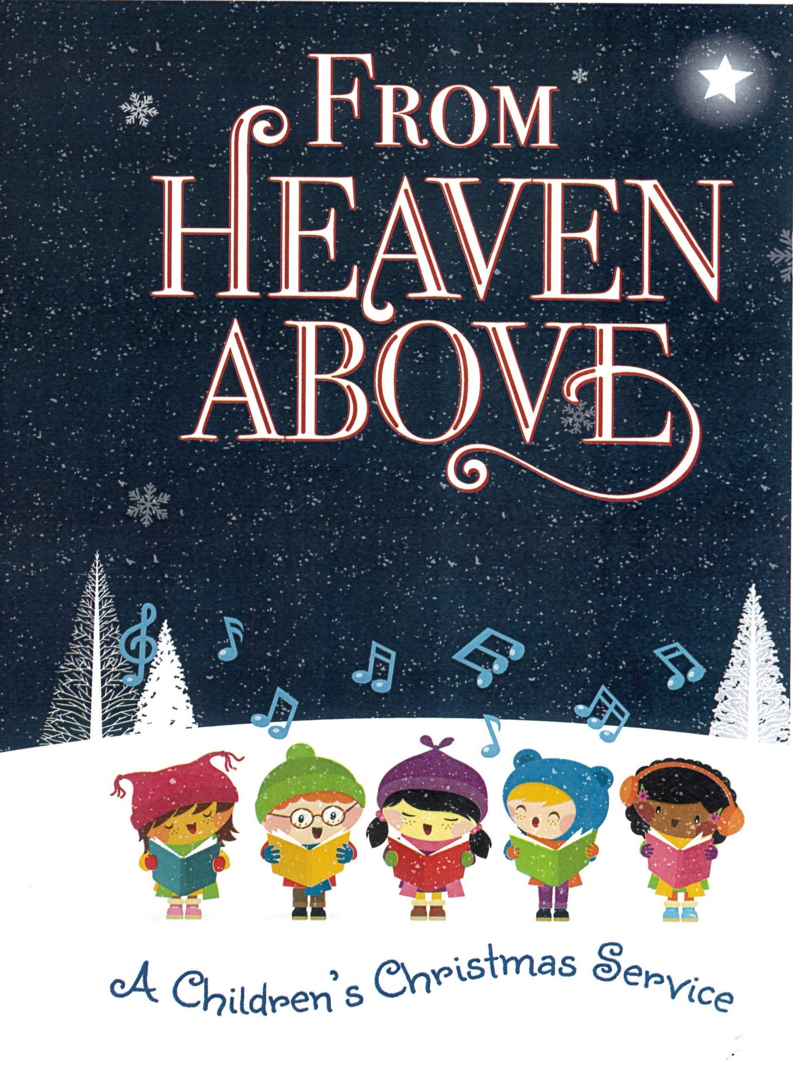
December 24, 2025 4:00 pm Mount Olive Lutheran Church
From Heaven Above

A Children’s Christmas Service For Young Children

Reflecting the joy within his family, Martin Luther wrote this hymn for his children’s Christmas Eve celebration either in 1534 or 1535. The pattern of a pre-Reformation singing game gave Luther’s simple hymn structure. Stanzas 1–5 report what the angels said. Stanzas 6 and 15 give voice to the family’s response, while stanzas 7–14 make application of the angel’s good news. Originally, Luther used the tune of the singing game, especially since the hymn was sung in the family. When the hymn began to be used in church services, Luther provided as a new tune the one used here.
From The Hymns of Martin Luther, copyright © 2016 Concordia Publishing House, pp. 26–27.

Processional Hymn From Heaven Above To Earth I Come LSB 358:1-2, 5-6, 13-15
Congregation:
“From heav’n above to earth I come
To bear good news to ev’ry home;
Glad tidings of great joy I bring,
Whereof I now will say and sing:

Congregation:
“To you this night is born a child
Of Mary, chosen virgin mild;
This little child of lowly birth
Shall be the joy of all the earth.

Soloist::
“These are the signs that you shall mark:
The swaddling clothes and manger dark.
There you will find the infant laid
By whom the heav’ns and earth were made.”

Congregation:
How glad we’ll be to find it so!
Then with the shepherds let us go
To see what God for us has done
In sending us His own dear Son.

Children:
Ah, dearest Jesus, holy Child
Prepare a bed, soft, undefiled,
A quiet chamber set apart
For You to dwell within my heart.

Congregation:
My heart for very joy must leap;
My lips no more can silence keep.
I, too, must sing with joyful tongue
That sweetest ancient cradlesong.

Children and Congregation:
Glory to God in highest heav’n,
Who unto us His Son has giv’n!
While angels sing with pious mirth
A glad new year to all the earth.

Invocation
Pastor: In the name of the Father and of the Son and of the Holy Spirit.
All: Amen.

Responsive Reading
Leader: From heaven above,
People: The angels sing.
Leader: On earth below,
People: Our praises bring.
Leader: Our Lord has come,
People: With us to dwell.
Leader: Now we go out:
People: Good News to tell!

Song: Christmas Song Children Songs of the Church Year, p. 8

Homily

Offering

The Message Presented By The Children

The Story of Jesus’ Birth

Reading: Luke 2:1-7

Hymn: Away In A Manger 5th/6th Grade Girls

Action Rhyme: Coming Down From Heaven Above

Hymn: What Child Is This Congregation

What child is this who laid to rest,

On Mary’s lap is sleeping?

Whom angels greet with anthems sweet

While shepherds watch are keeping?

This, this is Christ the King

Whom shepherds guard and angels sing;

Haste, haste to bring Him laud,

The babe, the son of Mary!

Why lies He in such mean estate

Where ox and ass are feeding?

Good Christian, fear, for sinners here

The silent Word is pleading.

Nails, spear shall pierce Him through,

The cross be borne for me, for you;

Hail, hail the Word made flesh,

The babe, the son of Mary!

So bring Him incense, gold, and myrrh;

Come, peasant, king to own Him.

The King of kings salvation brings,

Let loving hearts enthrone Him.

Raise, raise the song on high,

The virgin sings her lullaby;

Joy, joy for Christ is born,

The babe, the son of Mary!

Reading: Luke 2:8-14

Hymn: Angels We Have Heard On High LSB 368

Congregation and children:

Angels we have heard on high,

Sweetly singing o’er the plains,

And the mountain in reply,

Echoing their joyous strains.

Refrain:

Gloria in excelsis Deo.

Gloria in excelsis Deo.

Shepherds, why this jubilee?

Why your joyous strains prolong?

What the gladsome tiding be

Which inspire your heav’nly song? Refrain

Come to Bethlehem and see

Him whose birth the angels sing;

Come, adore on bended knee

Christ the Lord, the newborn King. Refrain

Recitation – Angels

Hymn: O Come, All Ye Faithful Congregation

O come, all ye faithful,

Joyful and triumphant!

O come ye, O come ye to Bethlehem.

Come and behold Him

Born the King of angels!

Refrain

O come, let us adore Him,

O come, let us adore Him,

O come, let us adore Him,

Christ the Lord!

Highest, most holy,

Light of light eternal,

Born of a Virgin, a mortal He comes;

Son of the Father

Now in flesh appearing! Refrain

Sing, choirs of angels,

Sing in exultation!

Sing, all ye citizens of heaven above!

Glory to God

In the highest. Refrain

Reading: Luke 2:15-20

Hymn: Where Shepherds Lately Knelt Children

Recitation

Responsive Reading

Leader: From heaven above,

People: The angels sing.

Leader: On earth below,

People: Our praises bring.

Leader: Our Lord has come.

People: With us to dwell.

Leader: Now we go out;

All: Good News to tell!

Hymn: Go Tell It On The Mountain Children

Prayer

Pastor: We pray:

All: Father in heaven, You sent Your Son to earth to be our Savior. You sent the angels down to tell the Good News. You sent the shepherds out to tell the Good News. And You send us now to tell the Good News. Help us share the message of your love throughout the world. In His name we pray. Amen.

Benediction

Pastor: The Lord above is with you wherever you go. May the peace of the Father, the (+) Son, and the Holy Spirit be with you every day as you tell of His love to others.

C: Amen.

Hymn: Joy To The World Congregation LSB 387

1 Joy to the world, the Lord is come!
Let earth receive her King;
Let ev’ry heart prepare Him room
And heav’n and nature sing,
And heav’n and nature sing,
And heav’n, and heav’n and nature sing.

2 Joy to the earth, the Savior reigns!
Let men their songs employ,
While fields and floods, rocks, hills, and plains
Repeat the sounding joy,
Repeat the sounding joy,
Repeat, repeat the sounding joy.

3 No more let sins and sorrows grow
Nor thorns infest the ground;
He comes to make His blessings flow
Far as the curse is found,
Far as the curse is found,
Far as, far as the curse is found.

4 He rules the world with truth and grace
And makes the nations prove
The glories of His righteousness
And wonders of His love,
And wonders of His love,
And wonders, wonders of His love.

Text: Isaac Watts, 1674–1748
Text: Public domain

Our Performers
Mary—Sadie Ballweg
Joseph—Brayden Maleck
Angels—Adelia Black, Mya Greiber, Addy Steingraber, Emma Steingraber, Sophie Strohm
Shepherds—Evan Greiber, Gavin Greiber, John Treece
Readers—Blaire Ballweg, Graham Ballweg, Hallie Black, Emma Bluhm, Joseph Bluhm, Arianna Maleck, Bethany Torkelson
Vocalists—Blaire Ballweg, Hallie Black, Arianna Maleck
Organist—Jonathan Torkelson
THANK YOU to Megan Ballweg and Kelsey Greiber for their assistance with costumes, rehearsals, and anything we needed!



Copyright © 2017 Concordia Publishing House
3558 S. Jefferson Ave., St. Louis, MO 63118-3968
1-800-325-3040 ● www.cph.org

All rights reserved. No part of this publication may be reproduced, stored in a retrieval system, or transmitted, in any form or by any means, electronic, mechanical, photocopying, recording, or otherwise, without purchasing this product from Concordia Publishing House. Through this registered purchase, your congregation is allowed to adapt and duplicate the contents for your local, one-time Christmas-program use.
Written by Lisa M. Clark
Edited by Lisa A. Krenz
Scripture quotations are from the ESV® Bible (The Holy Bible, English Standard Version®), copyright © 2001 by Crossway, a publishing ministry of Good News Publishers. Used by permission. All rights reserved.
Hymns marked LSB are from Lutheran Service Book, copyright © 2006 Concordia Publishing House. All rights reserved.
“Christmas Song” is from Songs of the Church Year, copyright © 2013 Concordia Publishing House. All rights reserved.
Manufactured in the United States of America
