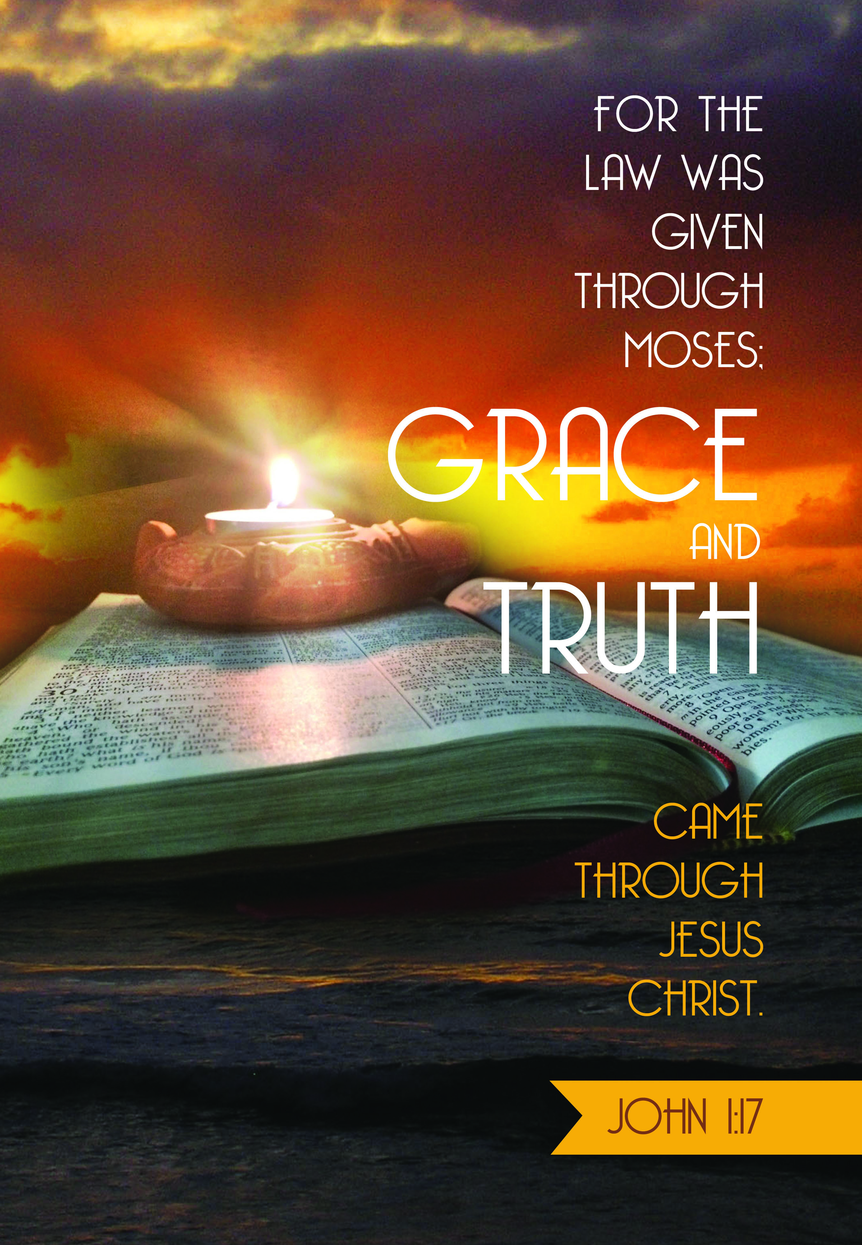

Now…GRACE!
December 25, 2025 9:00 am
Christmas Day Divine Service

Mount Olive Lutheran Church
110 N. Whitney Way
Madison, WI 53705

OPENING HYMN O Jesus So Sweet, O Jesus So Mild LSB 546
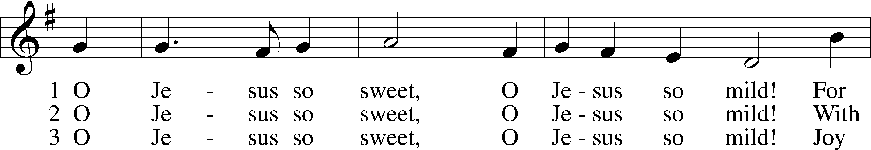
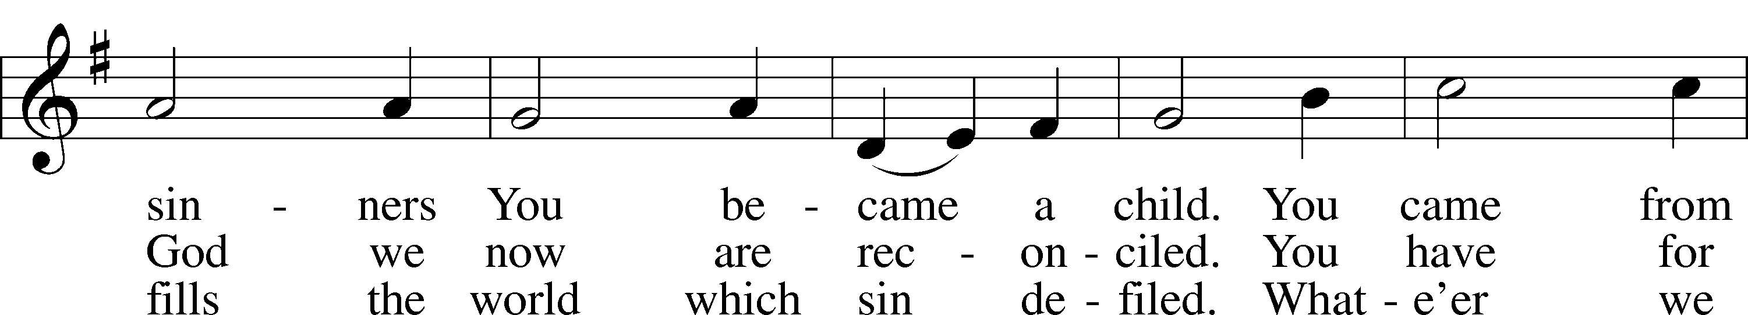
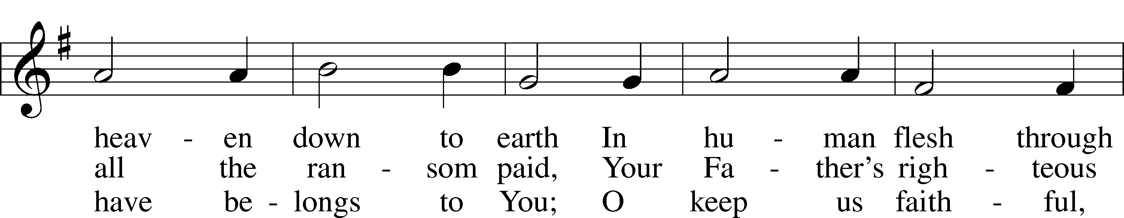
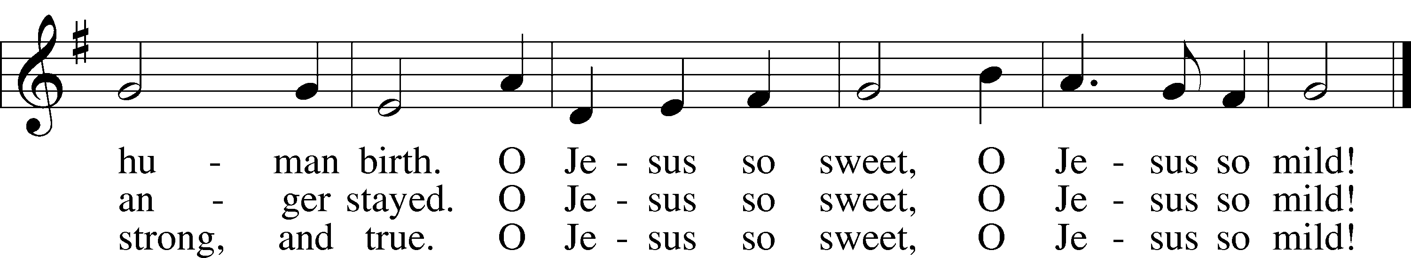
Text: Valentin Thilo, 1607–62, abr.; (st. 1): tr. Geoffrey W. Daisley, 1877–1939, alt.; (sts. 2–3): tr. Frieda Pietsch, 1904–82, alt.
Tune: Geistliche Kirchengesäng, 1623, Köln
Text and tune: Public domain

OPENING SENTENCES
P The Lord Himself will give you a sign.
C Behold, the virgin shall conceive and bear a son, and shall call His name Immanuel.

P In those days Judah will be saved and Jerusalem will dwell securely.
C And this is the name by which it will be called: “The Lord is our righteousness.”

CONFESSION OF SINS AND ABSOLUTION LSB 184
P Almighty God, our maker and redeemer, we poor sinners confess unto You that we are by nature sinful and unclean and that we have sinned against You by thought, word, and deed. Wherefore we flee for refuge to Your infinite mercy, seeking and imploring Your grace for the sake of our Lord Jesus Christ.
C O most merciful God, who has given Your only-begotten Son to die for us, have mercy upon us and for His sake grant us remission of all our sins; and by Your Holy Spirit increase in us true knowledge of You and of Your will and true obedience to Your Word, to the end that by Your grace we may come to everlasting life; through Jesus Christ, our Lord. Amen.
P Upon this your confession, I, by virtue of my office, as a called and ordained servant of the Word, announce the grace of God unto all of you, and in the stead and by the command of my Lord Jesus Christ I forgive you all your sins in the name of the Father and of the T Son and of the Holy Spirit.
C Amen.

INTROIT Psalm 98:1–4; antiphon: Isaiah 9:6
For to us a child is born, to us a son is given;
and the government shall be upon his shoulder,
and his name shall be called Wonderful Counselor,
Mighty God, Everlasting Father, Prince of Peace.
Oh sing to the Lord a new song, for he has done marvelous things!
His right hand and his holy arm have worked salvation for him.
The Lord has made known his salvation;
he has revealed his righteousness in the sight of the nations.
He has remembered his steadfast love and faithfulness to the house of Israel.
All the ends of the earth have seen the salvation of our God.
Make a joyful noise to the Lord, all the earth;
break forth into joyous song and sing praises!
Glory be to the Father and to the Son and to the Holy Spirit;
as it was in the beginning, is now, and will be forever. Amen.
For to us a child is born, to us a son is given;
and the government shall be upon his shoulder,
and his name shall be called Wonderful Counselor,
Mighty God, Everlasting Father, Prince of Peace.
KYRIE LSB 186
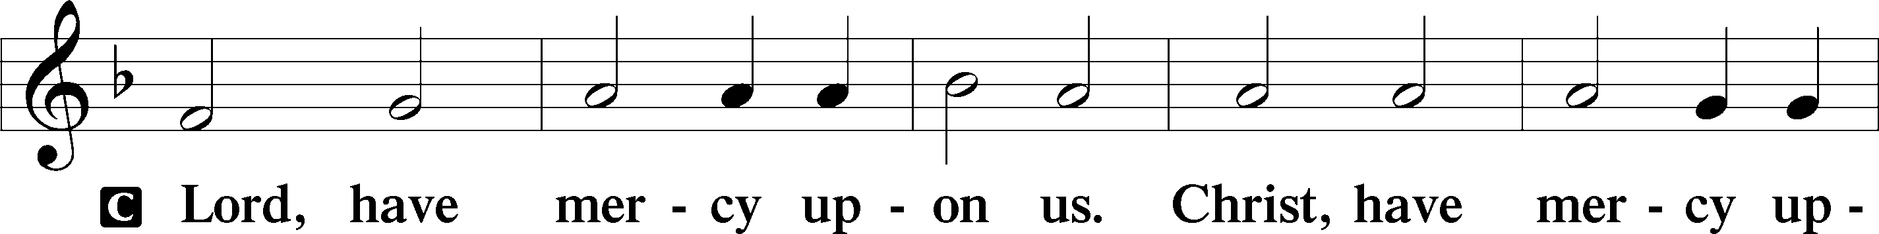
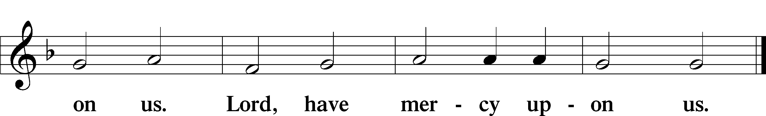

GLORIA HYMN Angels We Have Heard On High LSB 368
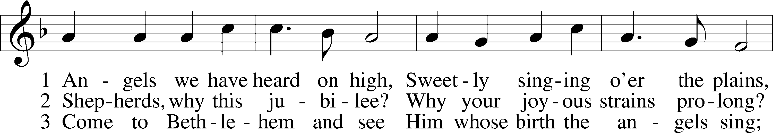
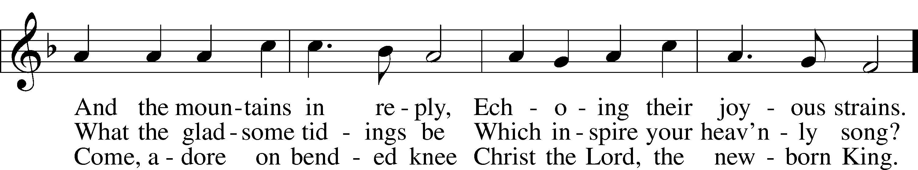
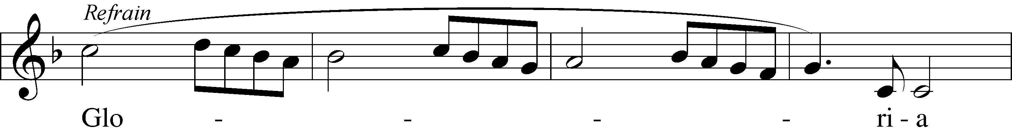
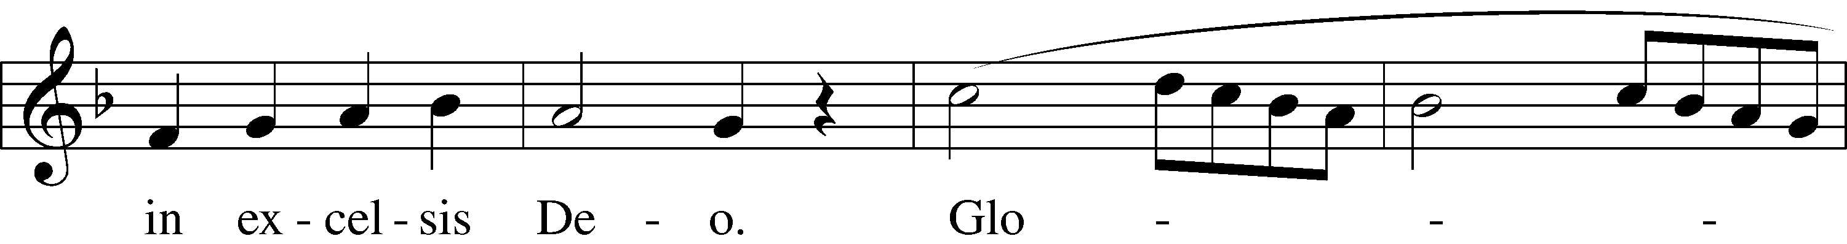
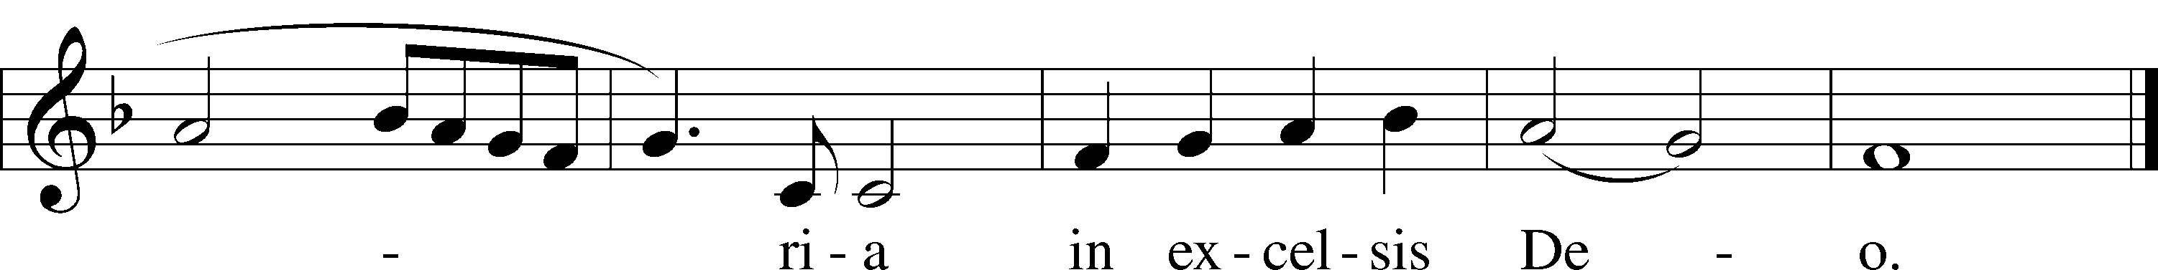
Text: tr. The Crown of Jesus, 1862, Part 2, London, alt.
Text and tune: French
Text and tune: Public domain

SALUTATION AND COLLECT OF THE DAY
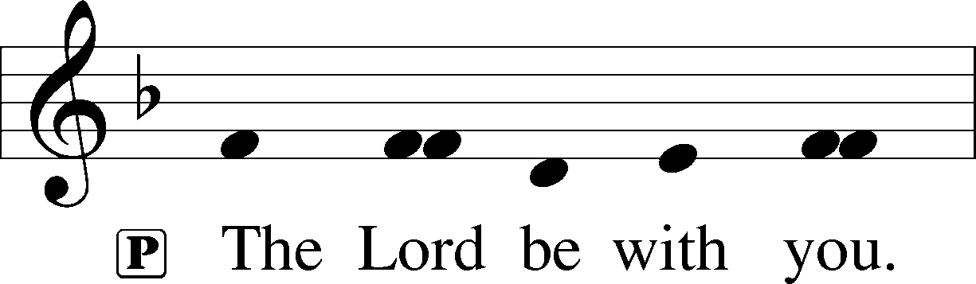
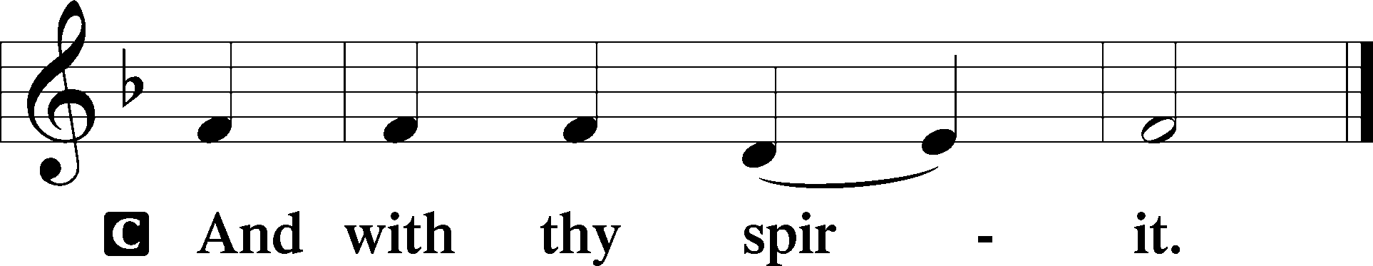
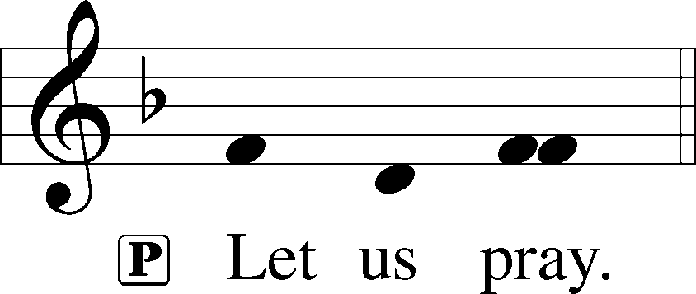
P Almighty God, grant that the birth of Your only-begotten Son in the flesh may set us free from the bondage of sin; through Jesus Christ, Your Son, our Lord, who lives and reigns with You and the Holy Spirit, one God, now and forever.
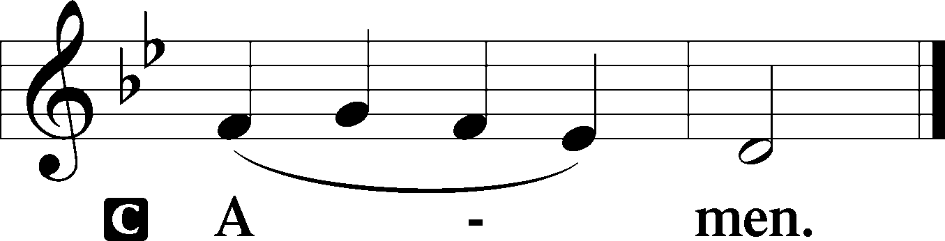

OLD TESTAMENT READING Isaiah 52:7–10
7How beautiful upon the mountains are the feet of him who brings good news, who publishes peace, who brings good news of happiness, who publishes salvation, who says to Zion, “Your God reigns.” 8The voice of your watchmen—they lift up their voice; together they sing for joy; for eye to eye they see the return of the Lord to Zion. 9Break forth together into singing, you waste places of Jerusalem, for the Lord has comforted his people; he has redeemed Jerusalem. 10The Lord has bared his holy arm before the eyes of all the nations, and all the ends of the earth shall see the salvation of our God.
A This is the Word of the Lord.
C Thanks be to God.

HYMN Of The Father’s Love Begotten LSB 384
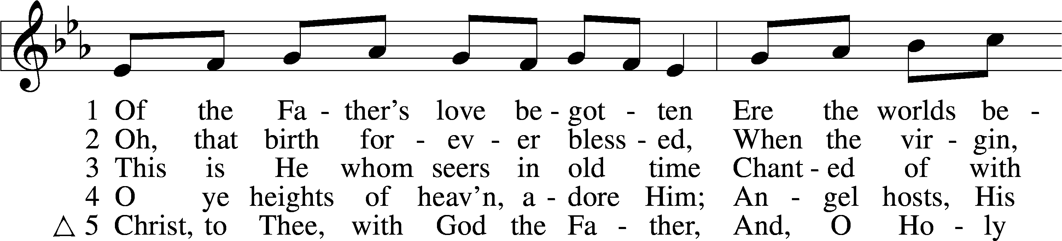
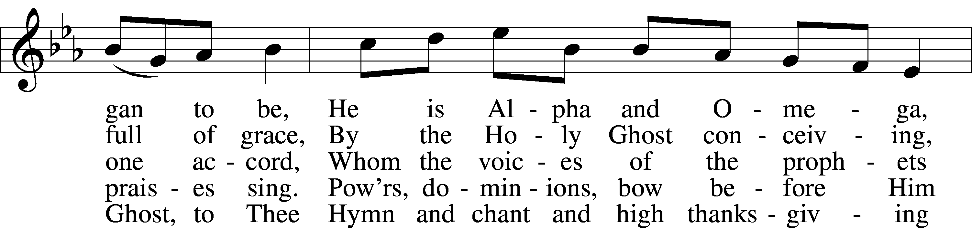
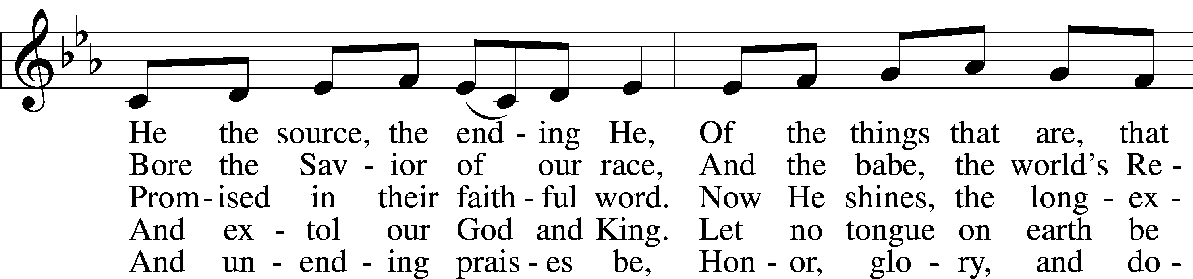
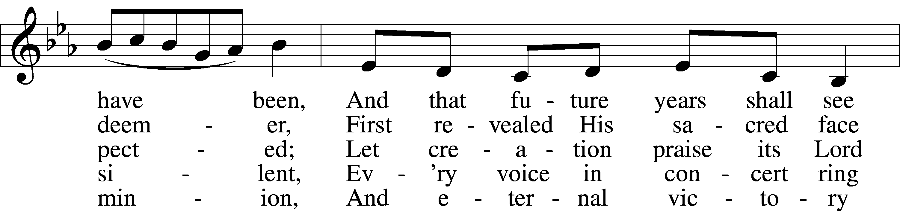
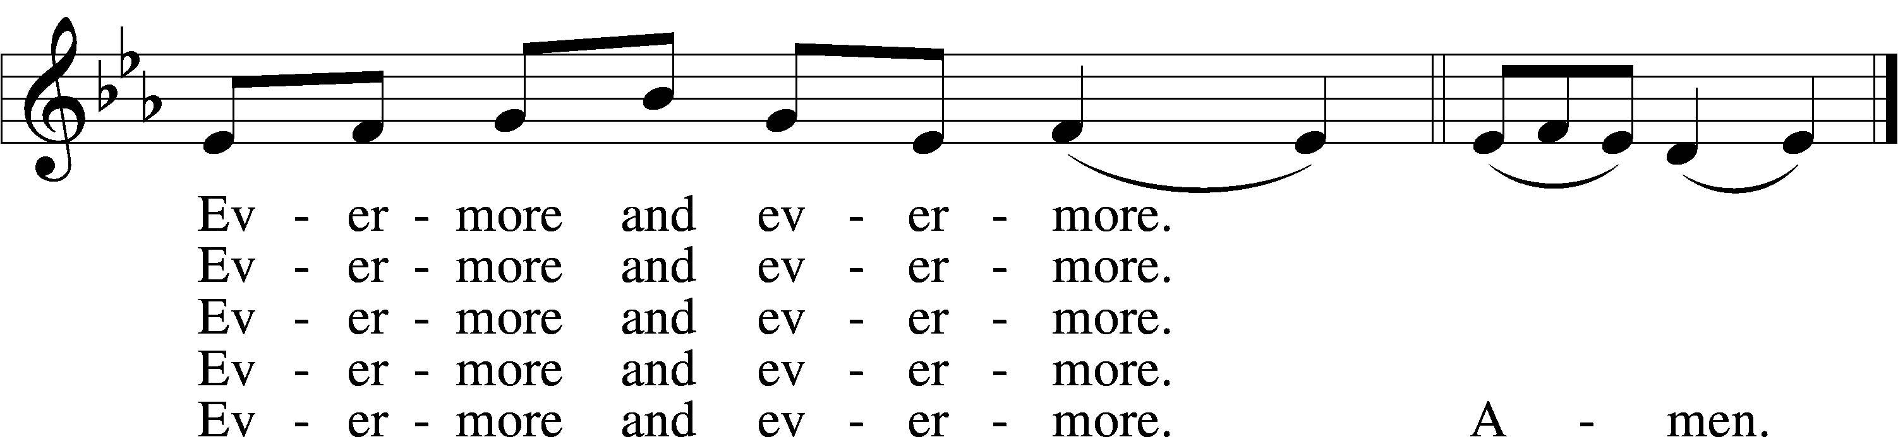
Text: Aurelius Prudentius Clemens, 348–c. 413; (sts. 1–4): tr. John Mason Neale, 1818–66, alt.; (st. 5): tr. Henry W. Baker, 1821–77
Tune: Plainsong, 13th cent., mode V
Text and tune: Public domain

EPISTLE Hebrews 1:1–12
1Long ago, at many times and in many ways, God spoke to our fathers by the prophets, 2but in these last days he has spoken to us by his Son, whom he appointed the heir of all things, through whom also he created the world. 3He is the radiance of the glory of God and the exact imprint of his nature, and he upholds the universe by the word of his power. After making purification for sins, he sat down at the right hand of the Majesty on high, 4having become as much superior to angels as the name he has inherited is more excellent than theirs.
5For to which of the angels did God ever say,
“You are my Son,
today I have begotten you”?
Or again,
“I will be to him a father,
and he shall be to me a son”?
6And again, when he brings the firstborn into the world, he says,
“Let all God’s angels worship him.”
7Of the angels he says,
“He makes his angels winds,
and his ministers a flame of fire.”
8But of the Son he says,
“Your throne, O God, is forever and ever,
the scepter of uprightness is the scepter of your kingdom.
9You have loved righteousness and hated wickedness;
therefore God, your God, has anointed you
with the oil of gladness beyond your companions.”
10And,
“You, Lord, laid the foundation of the earth in the beginning,
and the heavens are the work of your hands;
11they will perish, but you remain;
they will all wear out like a garment,
12like a robe you will roll them up,
like a garment they will be changed.
But you are the same,
and your years will have no end.”

A This is the Word of the Lord.
C Thanks be to God.

ALLELUIA LSB 190
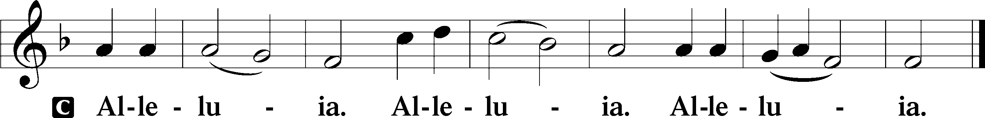

HOLY GOSPEL John 1:1–18
P The Holy Gospel according to St. John, the first chapter.
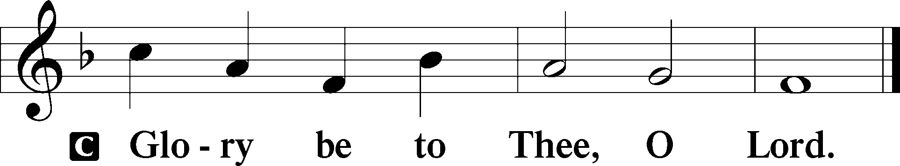

1In the beginning was the Word, and the Word was with God, and the Word was God. 2He was in the beginning with God. 3All things were made through him, and without him was not any thing made that was made. 4In him was life, and the life was the light of men. 5The light shines in the darkness, and the darkness has not overcome it.
6There was a man sent from God, whose name was John. 7He came as a witness, to bear witness about the light, that all might believe through him. 8He was not the light, but came to bear witness about the light.
9The true light, which enlightens everyone, was coming into the world. 10He was in the world, and the world was made through him, yet the world did not know him. 11He came to his own, and his own people did not receive him. 12But to all who did receive him, who believed in his name, he gave the right to become children of God, 13who were born, not of blood nor of the will of the flesh nor of the will of man, but of God.
14And the Word became flesh and dwelt among us, and we have seen his glory, glory as of the only Son from the Father, full of grace and truth. 15(John bore witness about him, and cried out, “This was he of whom I said, ‘He who comes after me ranks before me, because he was before me.’”) 16And from his fullness we have all received, grace upon grace. 17For the law was given through Moses; grace and truth came through Jesus Christ. 18No one has ever seen God; the only God, who is at the Father’s side, he has made him known.
P This is the Gospel of the Lord.
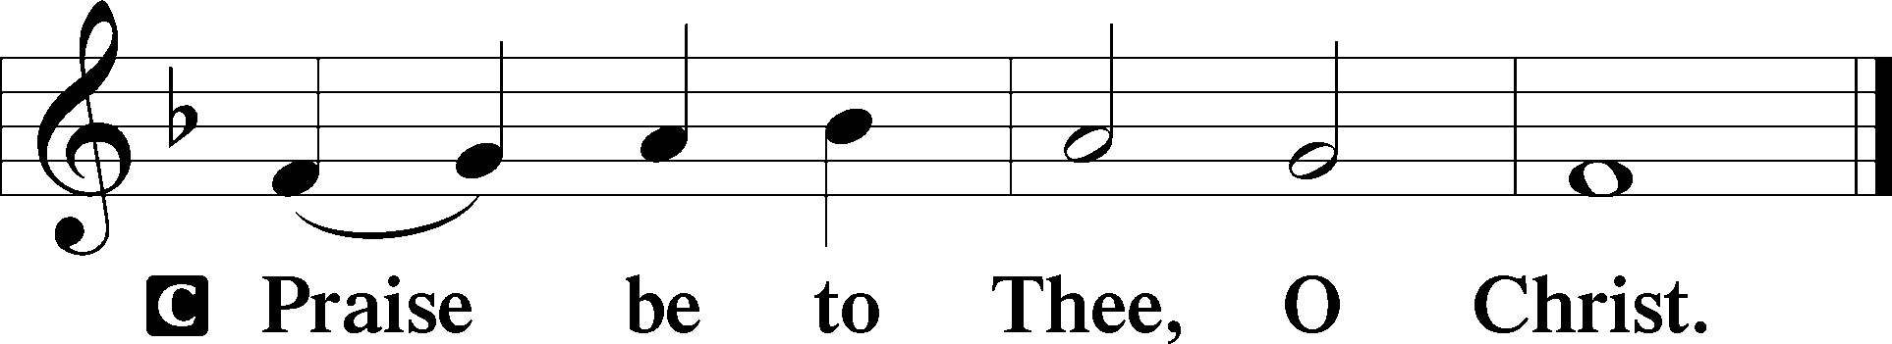

APOSTLES’ CREED
C I believe in God, the Father Almighty, maker of heaven and earth.
And in Jesus Christ, His only Son, our Lord, who was conceived by the Holy Spirit, born of the virgin Mary, suffered under Pontius Pilate, was crucified, died and was buried. He descended into hell. The third day He rose again from the dead. He ascended into heaven and sits at the right hand of God the Father Almighty. From thence He will come to judge the living and the dead.
I believe in the Holy Spirit, the holy Christian Church, the communion of saints, the forgiveness of sins, the resurrection of the body, and the life T everlasting. Amen.

HYMN OF THE DAY What Child Is This LSB 370
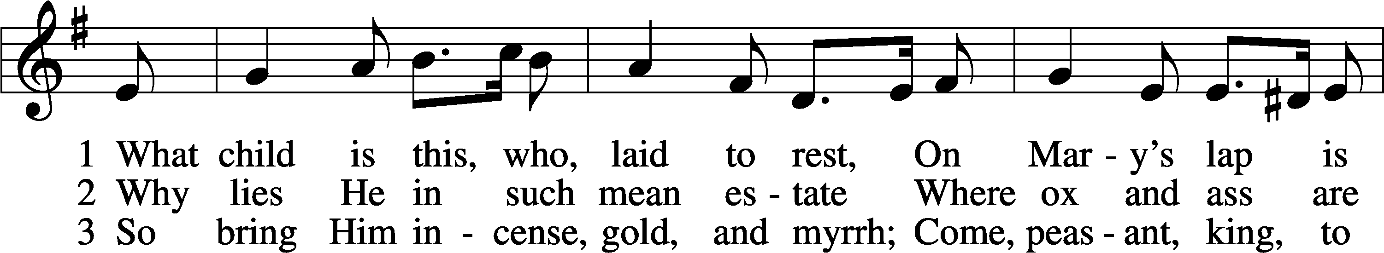
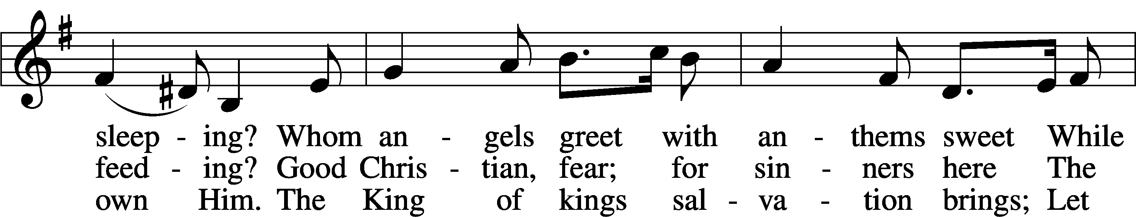
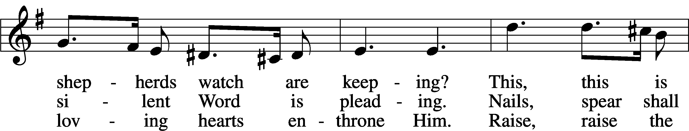
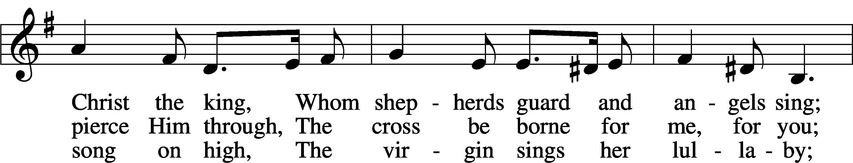
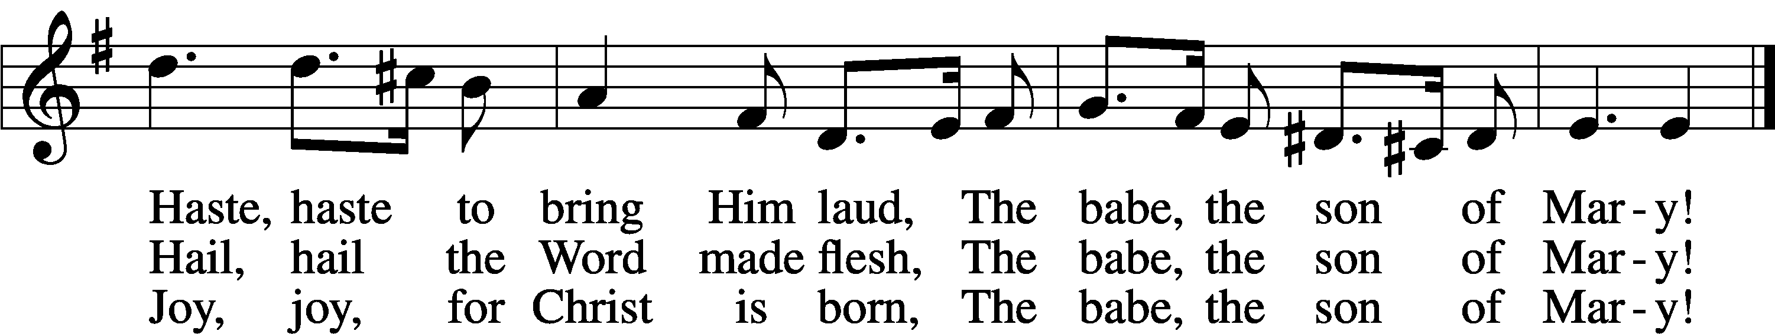
Text: William C. Dix, 1837–98
Tune: English, 16th cent.
Text and tune: Public domain

SERMON Now…GRACE! John 1:14-18

PRAYER OF THE CHURCH
After each petition:
P Lord, in your mercy, C hear our prayer.

OFFERING
Handbells He Is Born, The Divine Christ Child French Carol
Arr. Martha Lynn Thompson
OFFERTORY LSB 192
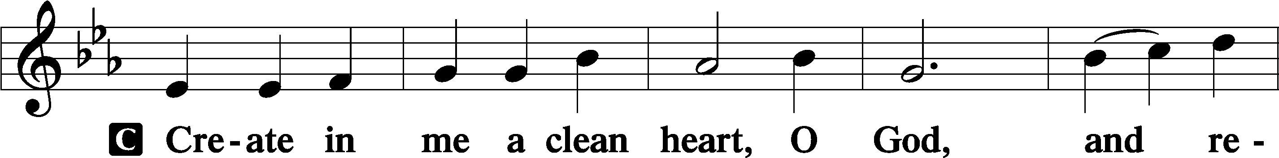
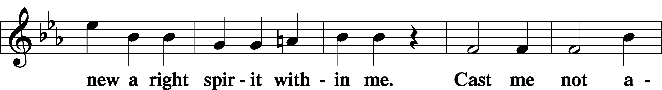
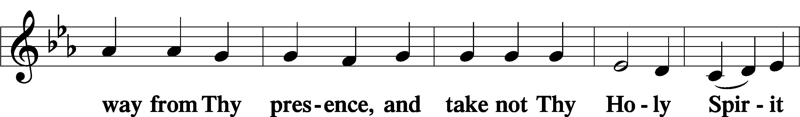
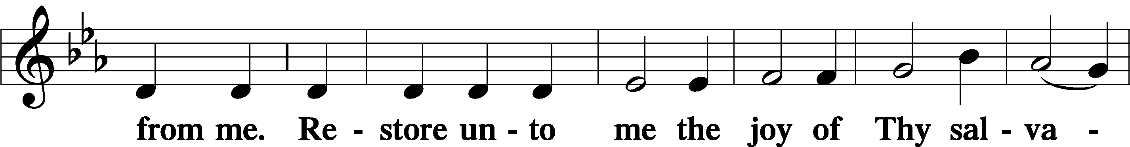
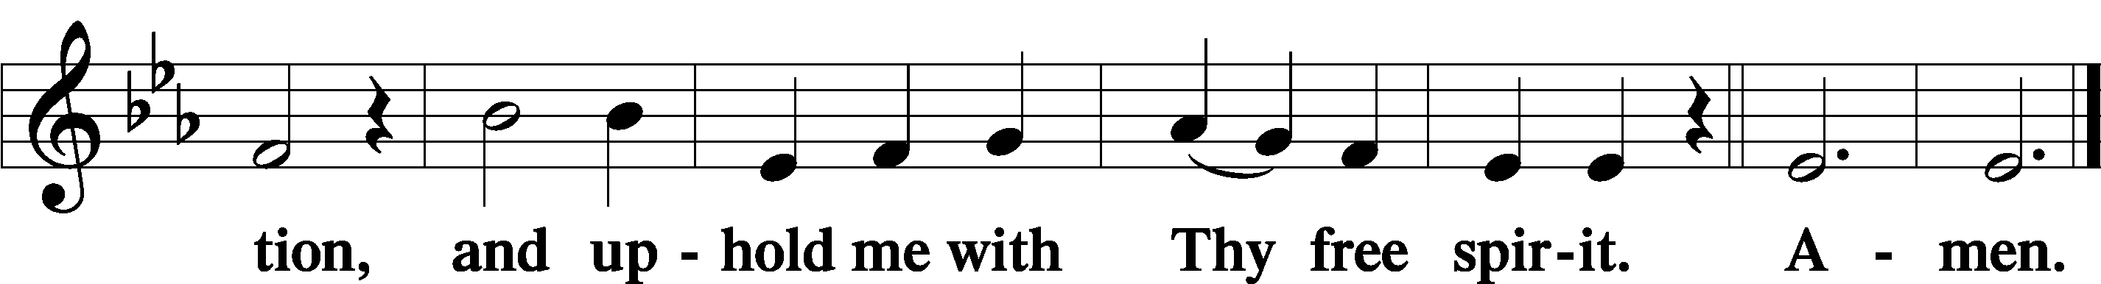

PREFACE LSB 194

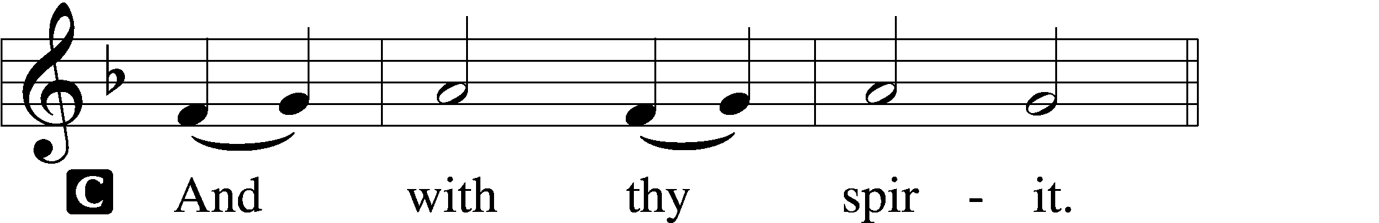

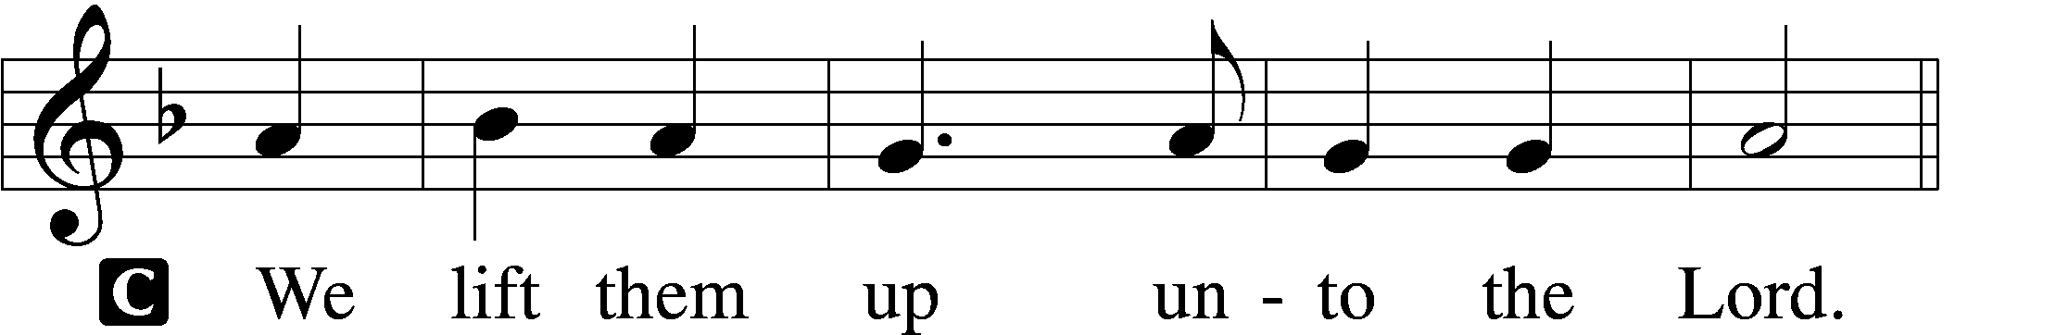
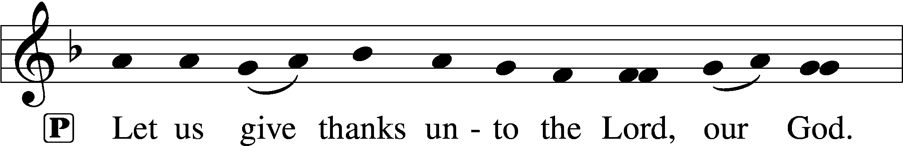
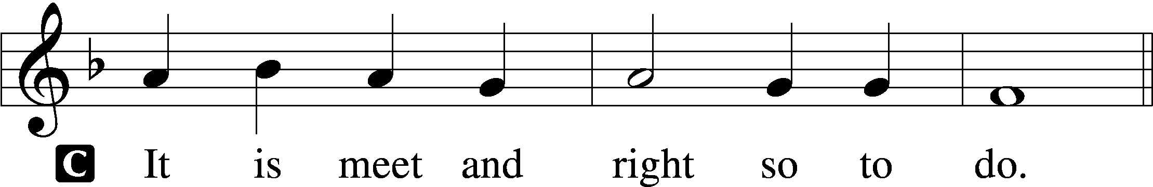

PROPER PREFACE (ABBREVIATED) LSB 194
P It is truly good, right, and salutary . . . evermore praising You and saying:
SANCTUS LSB 195
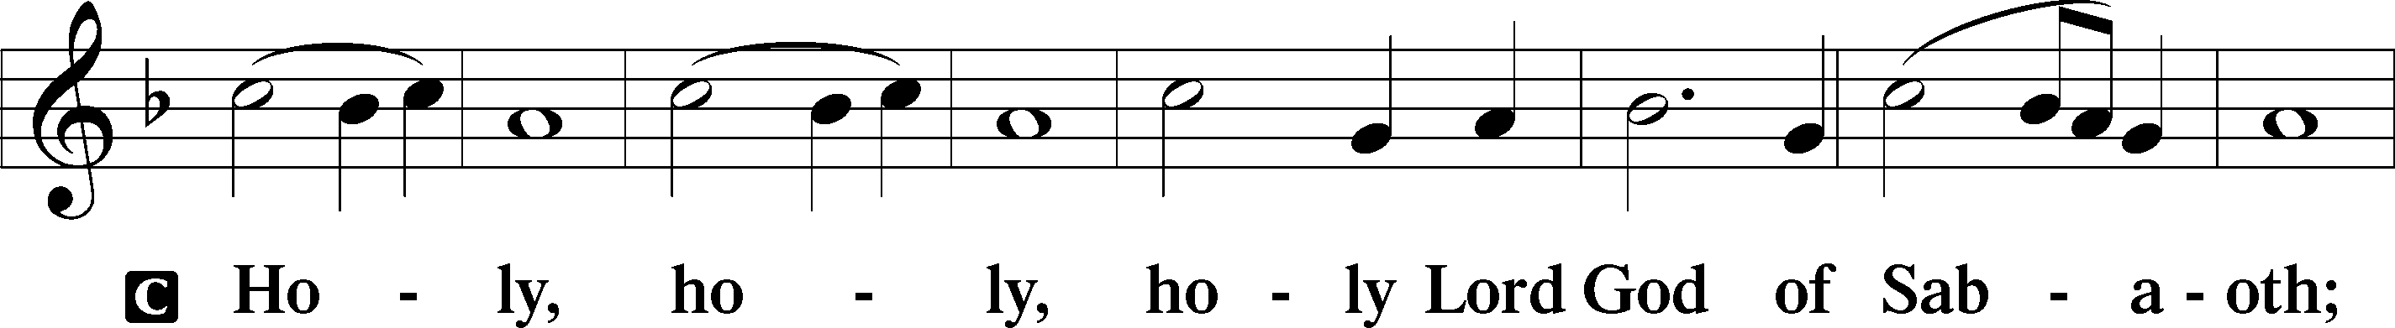
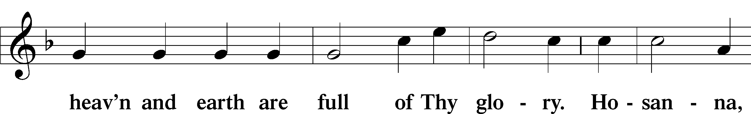
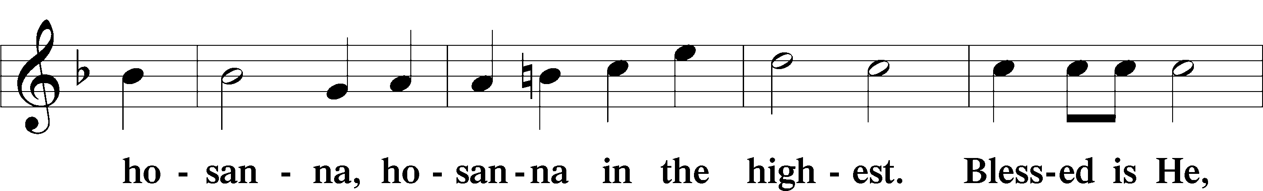
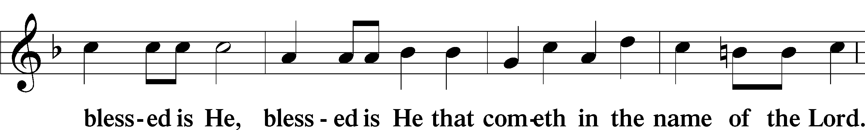
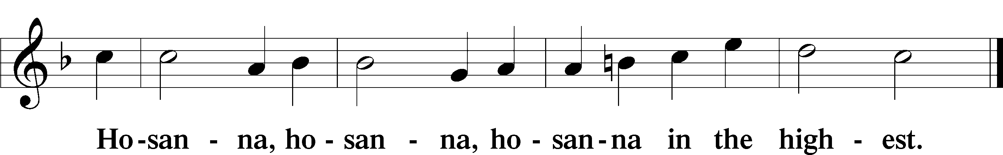

LORD’S PRAYER LSB 162
P Lord, remember us in Your kingdom and teach us to pray:
C Our Father who art in heaven, hallowed be Thy name, Thy kingdom come, Thy will be done on earth as it is in heaven; give us this day our daily bread; and forgive us our trespasses as we forgive those who trespass against us; and lead us not into temptation, but deliver us from evil. For Thine is the kingdom and the power and the glory forever and ever. Amen.

THE WORDS OF INSTITUTION LSB 197

PAX DOMINI LSB 197
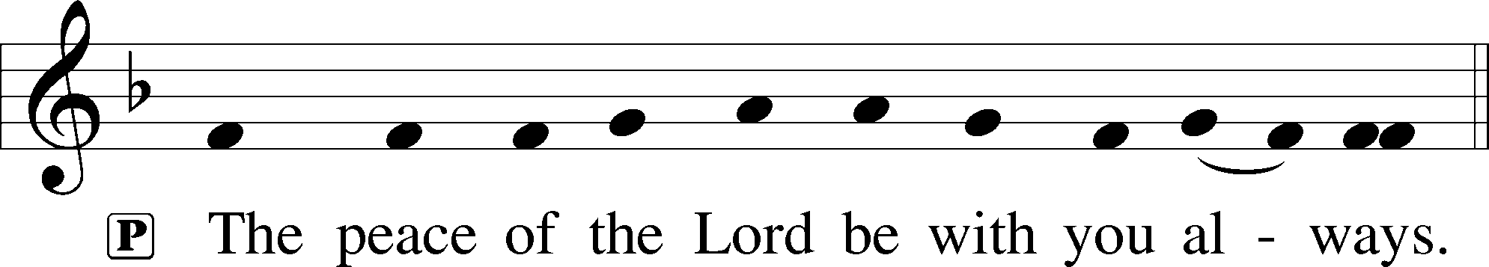
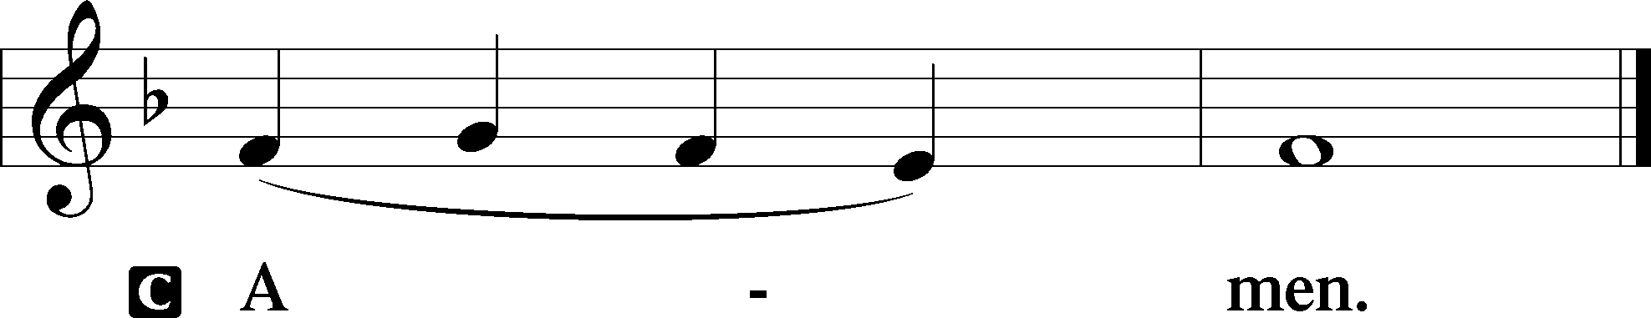

AGNUS DEI LSB 198
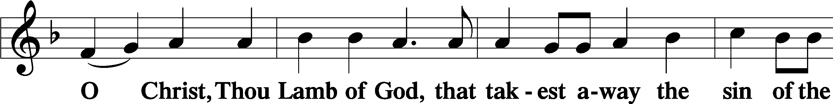
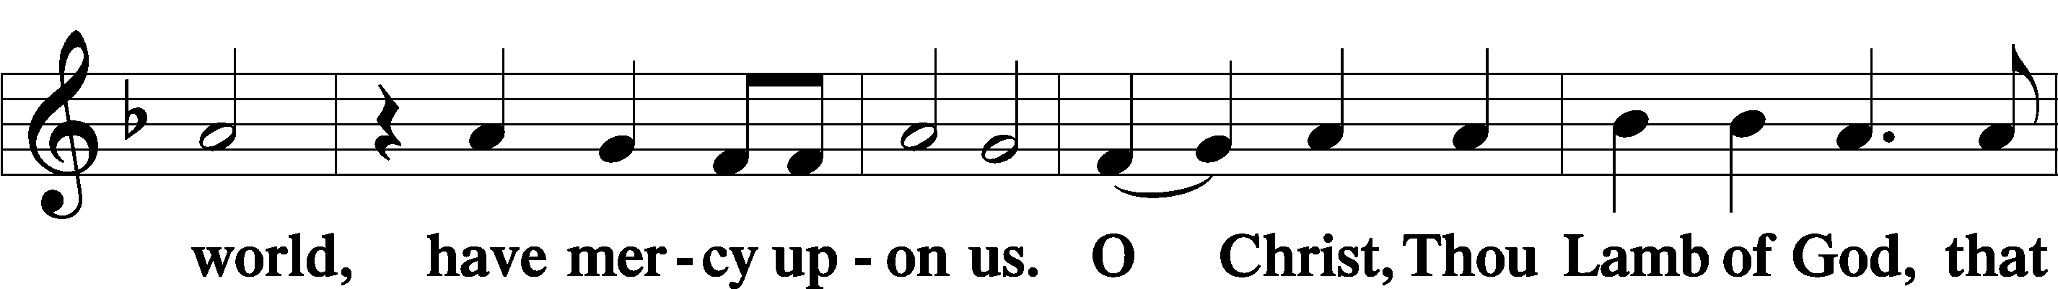
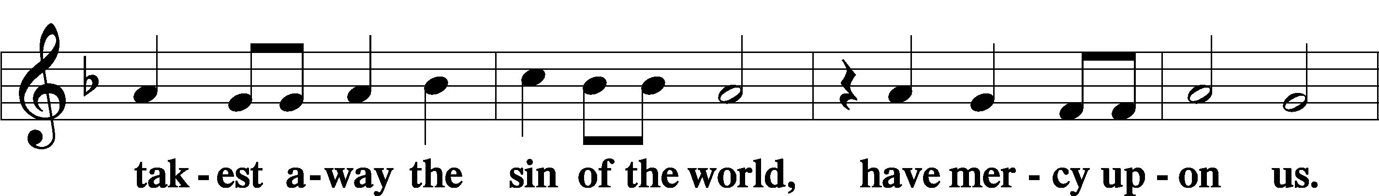
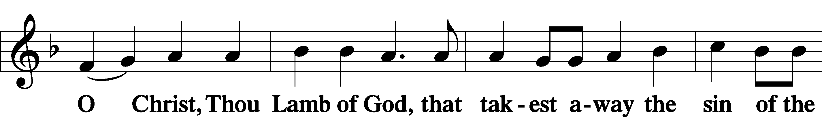
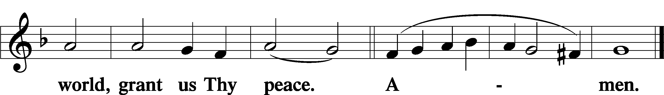

DISTRIBUTION
Hymns
Hark! The Herald Angels Sing! LSB 380
Angels From The Realms Of Glory LSB 367
See Amid The Winter’s Snow LSB 373

NUNC DIMITTIS LSB 199
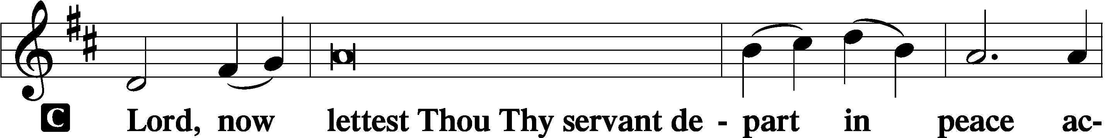
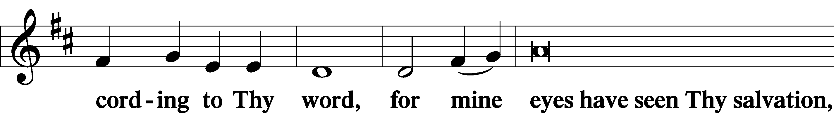
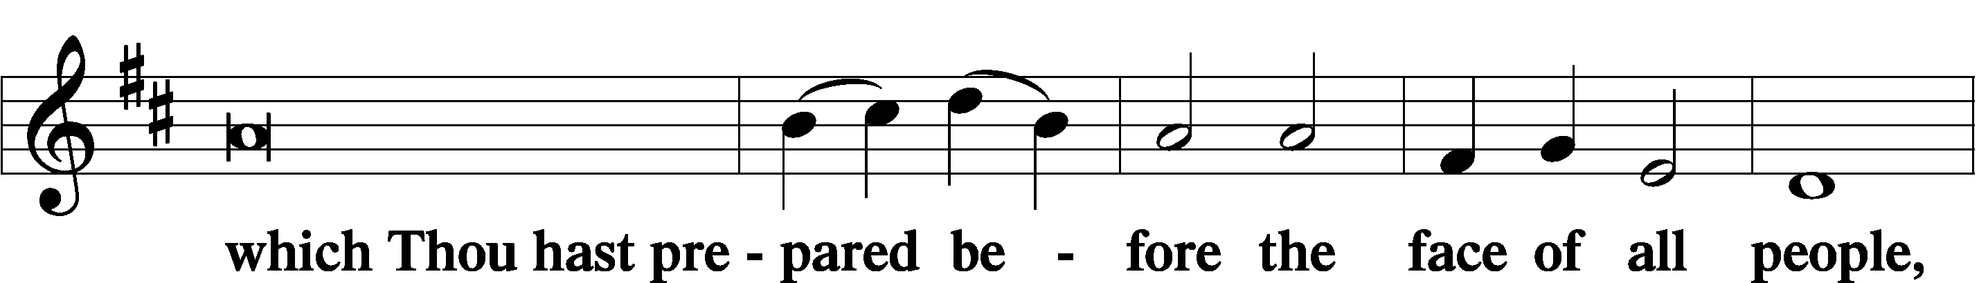
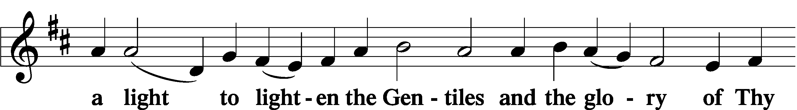
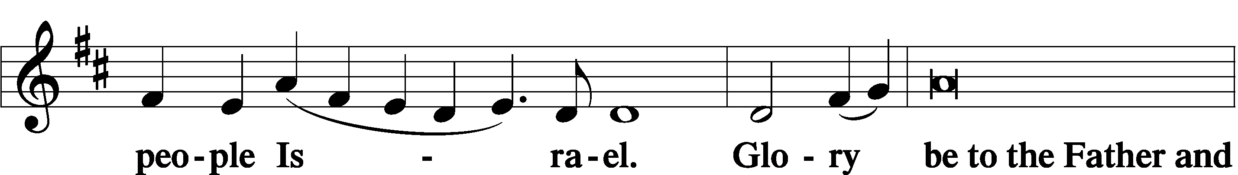
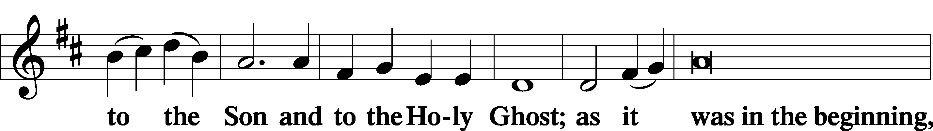
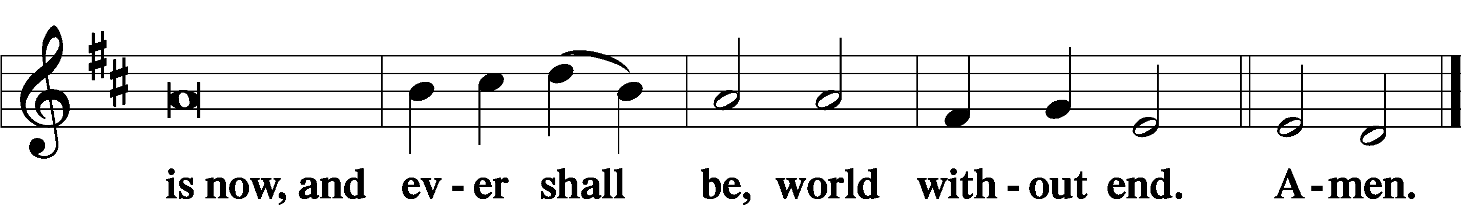

THANKSGIVING LSB 200
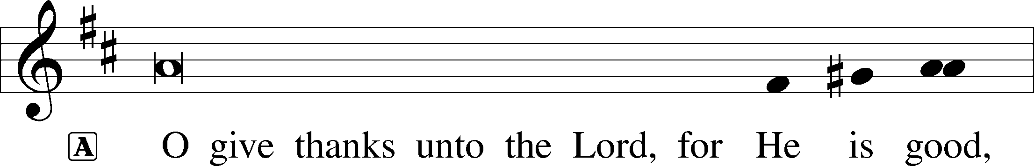
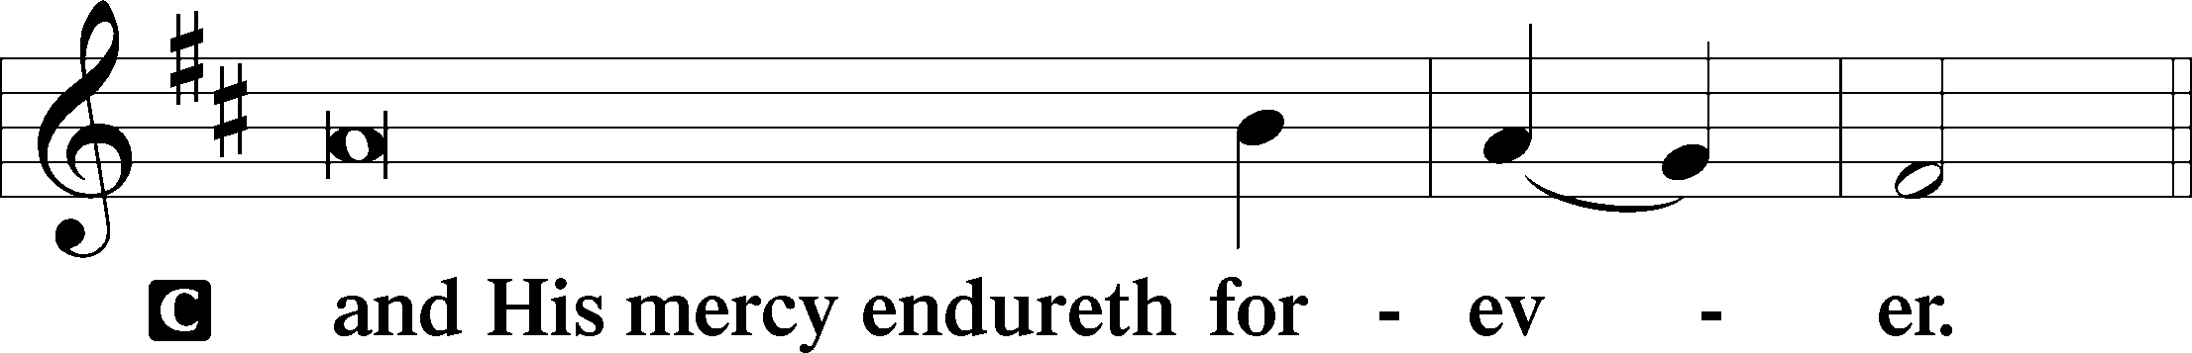

POST-COMMUNION COLLECT
A Let us pray.
We give thanks to You, almighty God, that You have refreshed us through this salutary gift, and we implore You that of Your mercy You would strengthen us through the same in faith toward You and in fervent love toward one another; through Jesus Christ, Your Son, our Lord, who lives and reigns with You and the Holy Spirit, one God, now and forever.
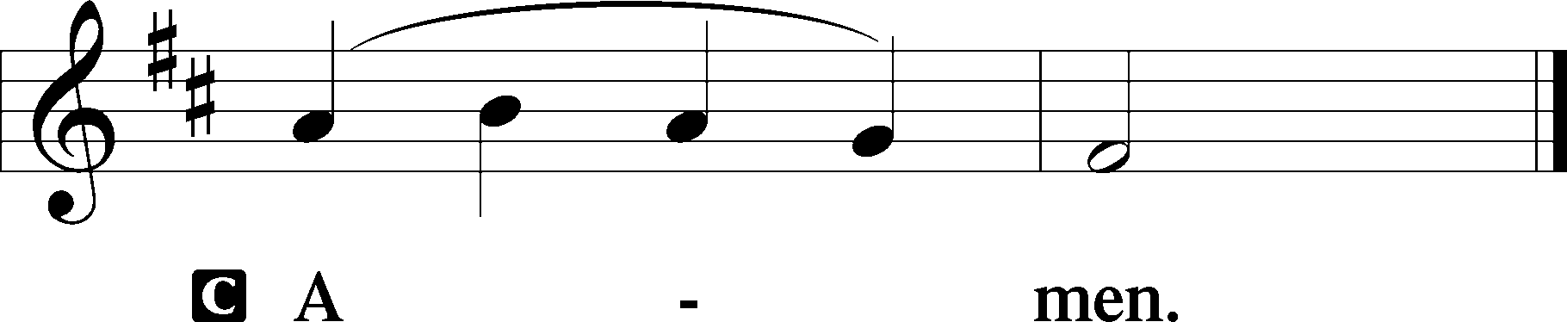

SALUTATION LSB 201
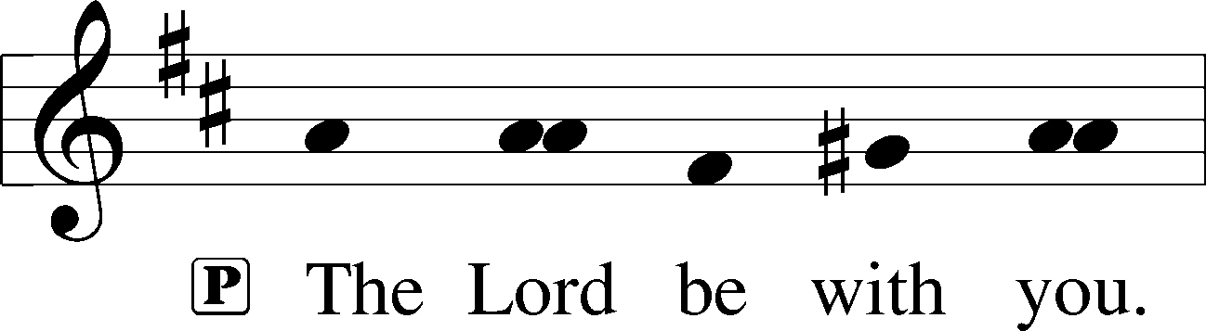
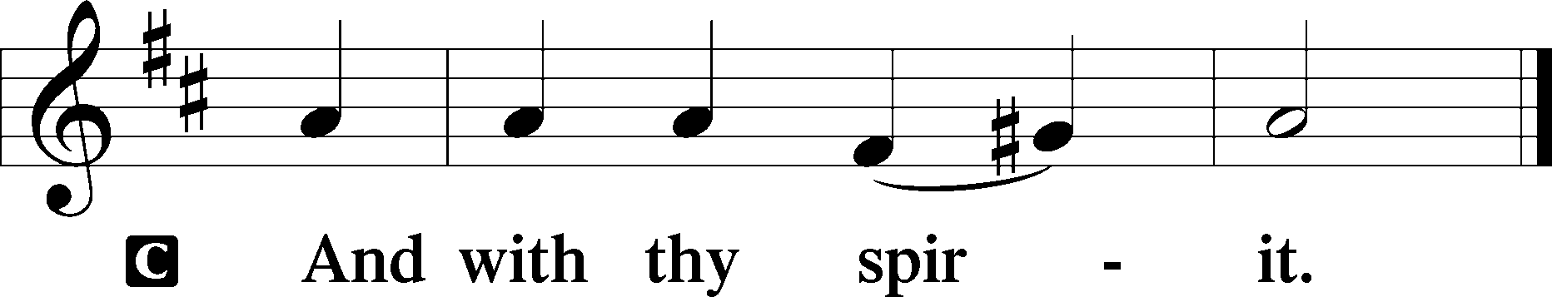

BENEDICAMUS LSB 202
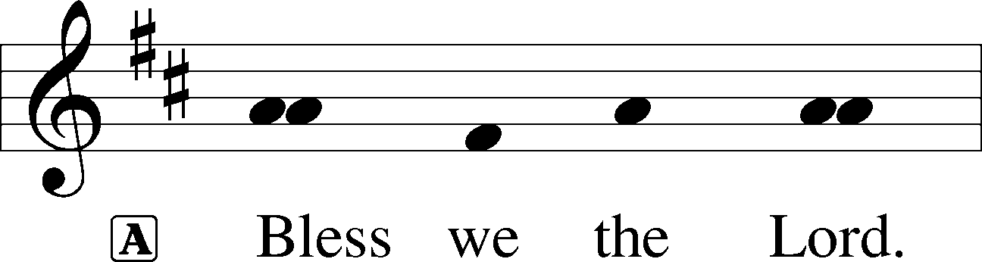
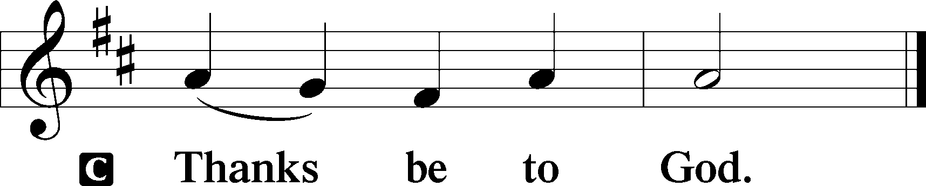

BENEDICTION LSB 202
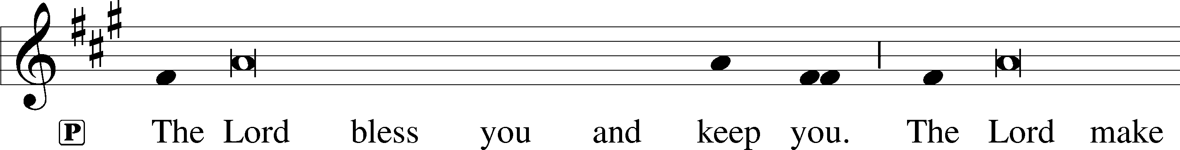
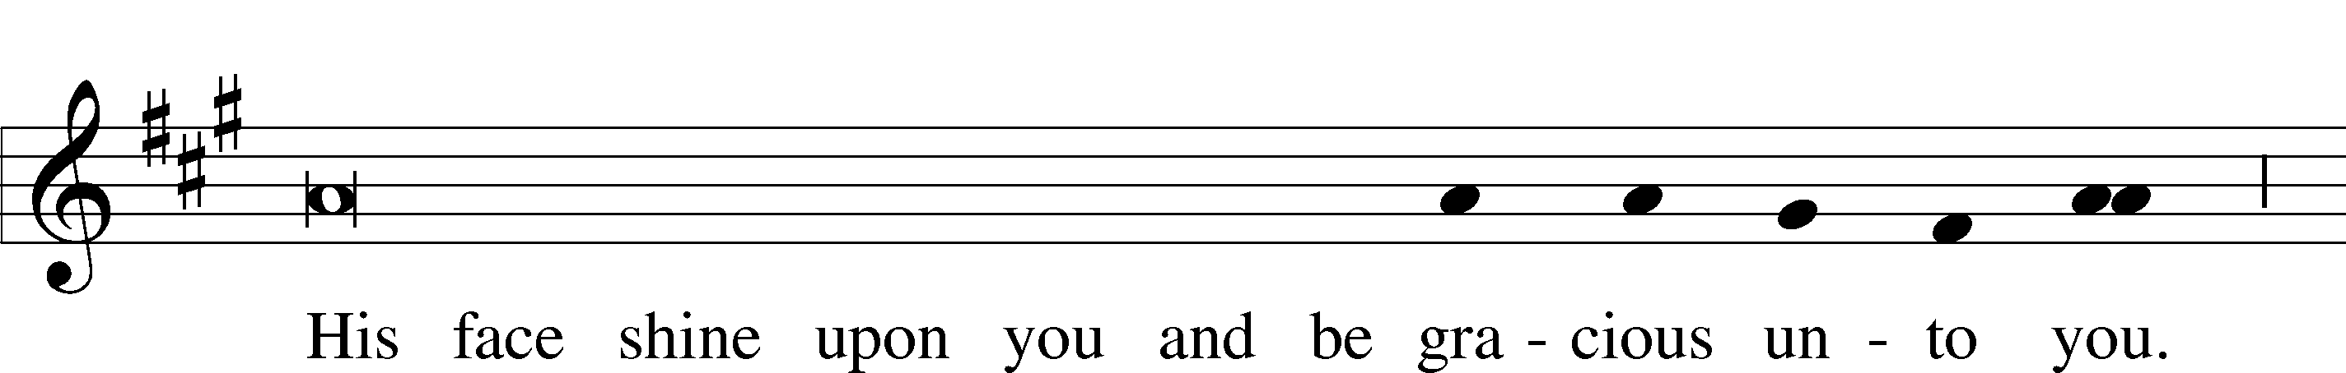
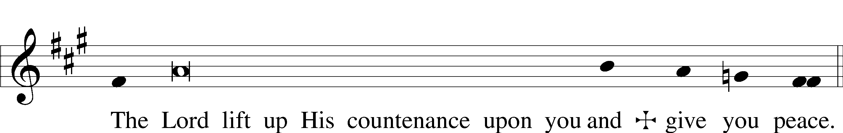
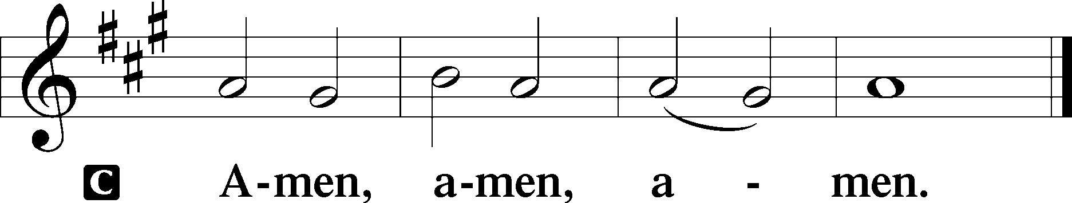

HYMN TO DEPART: JOY TO THE WORLD LSB 387
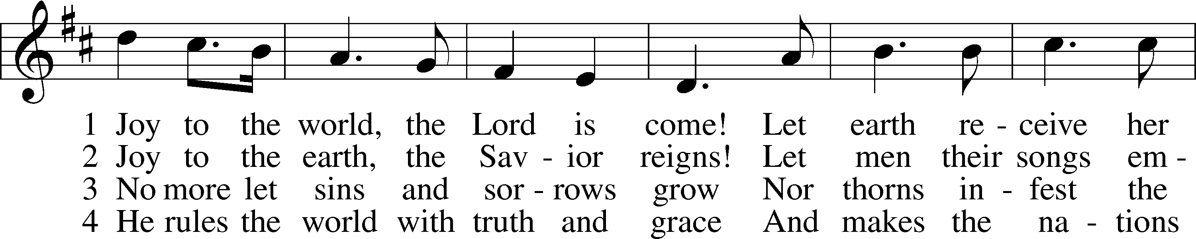
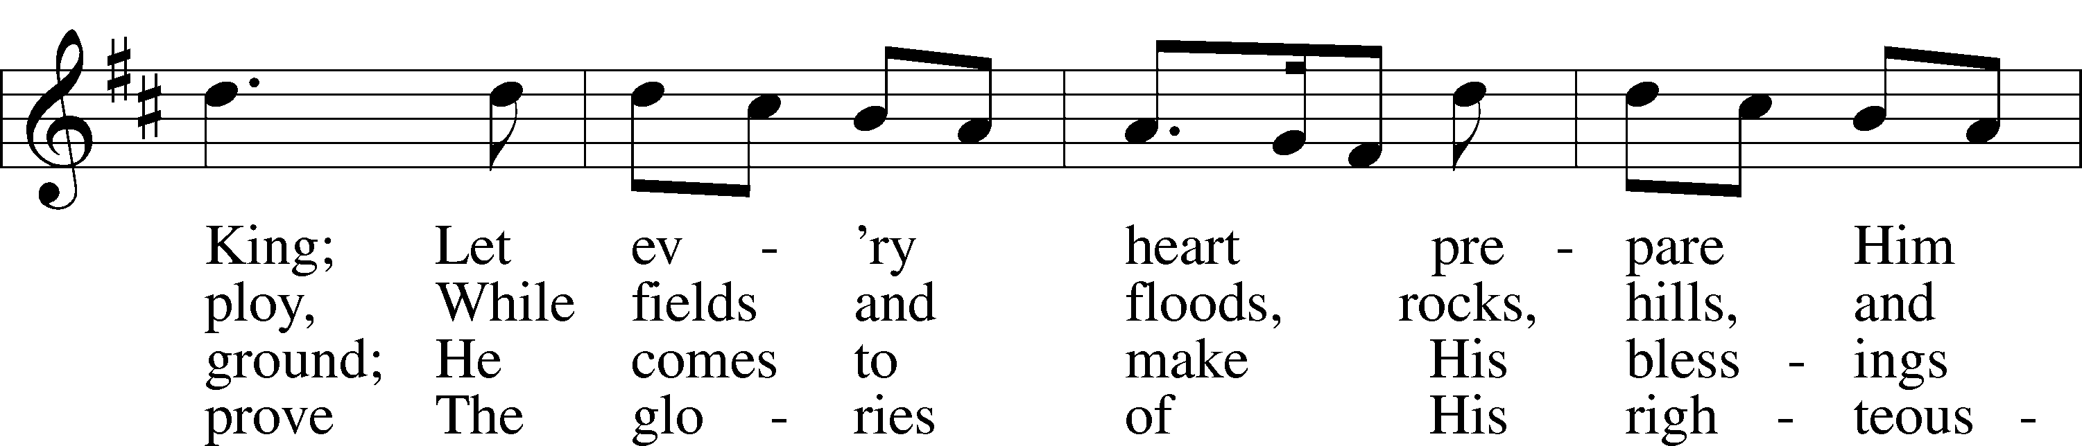
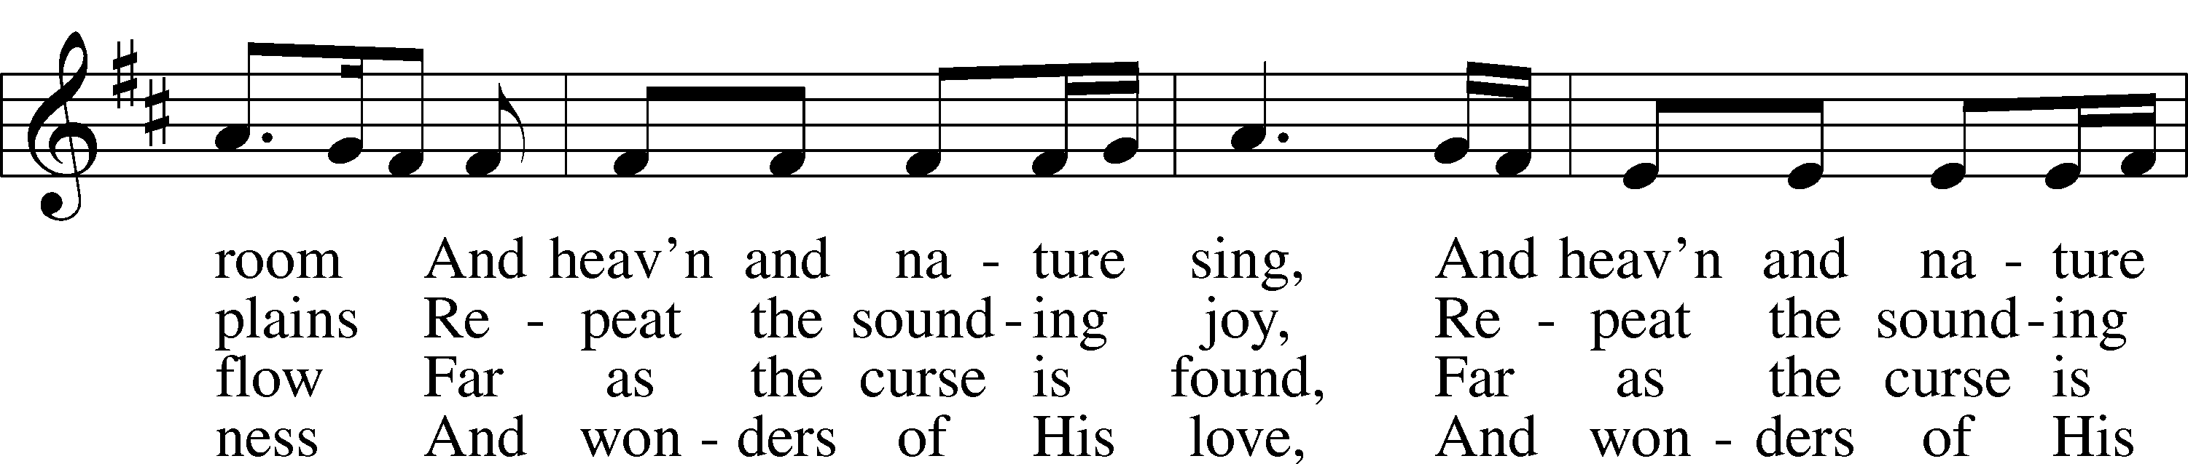
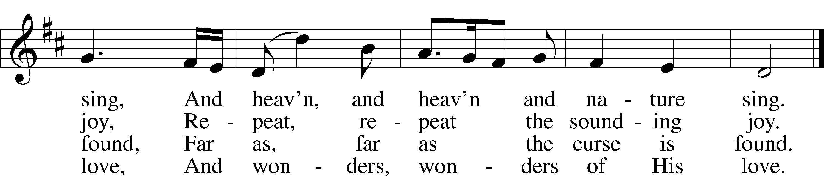
Text: Isaac Watts, 1674–1748
Tune: George Frideric Handel, 1685–1759, adapt.
Text and tune: Public domain

ACKNOWLEDGMENTS
Divine Service, Setting Three from Lutheran Service Book. Unless otherwise indicated, Scripture quotations are from the ESV® Bible (The Holy Bible, English Standard Version®), copyright © 2001 by Crossway, a publishing ministry of Good News Publishers. Used by permission. All rights reserved. Created by Lutheran Service Builder © 2025 Concordia Publishing House.

ANNOUNCEMENTS

DISMISSAL
P Go in peace. Serve the Lord!
C Thanks be to God.
POSTLUDE
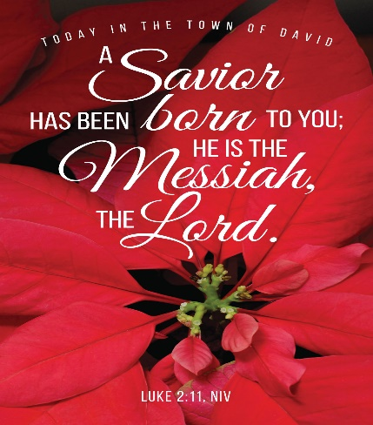
SERVANTS IN GOD’S HOUSE TODAY
Officiant: Pastor Dan Torkelson
Organist: Holly Sander
Elder: Zach Treece
Lector: Dave Kral
Audio/Visual: James Fenske, Barb Koehler
Usher Team: Cropp
Camera: Paul Skidmore
Altar Guild: Charisse Treece

ALTAR FLOWERS

Holly and Jerry Sander In memory of our Parents
Mike and Karen Stolen In Memory of our Parents
Gary and Peggy Rainbow In Memory of our Parents
Janelle Tonsager In Memory of my Dad, Joe (Arland) Goettsch
Marge Bils In Memory of Loved Ones
Sharon Klawitter In Memory of Loved Ones
Karen Weigt 4In Memory of Parents
Dave Gaston In Memory of Cindy Gaston, Carson and Eileen Lau, Jane Gaston
Lyle Christian In Memory of his Wife, Alberta and Mother, Ada
Pastor Mark & Marci Baldwin In Honor of our Grandchildren
Dave and Gloria Compton In Memory of John and Marilyn Compton and Ernst Groth
Steve and Joni Postler In Honor of our Grandchildren
Gene and Jo Schoohs In Honor of our Family
Curt and Sarah Casanova In Memory of Grace and Todd Casanova
Gary and Mary Strohm In Memory of our Parents
Zach and Charisse Treece
Peter and Audrey Morrison
Carol White
Eunice Gibson
Karen Goebel and Gerry Campbell
Jay and Sue Molter

